**Turn on/off LED with Blynk**

1. **Requirements**

* Use Wemos D1 wifi board
* Setup Blynk app on your smart phone
* Use Blynk to turn ON/OFF the LED

1. **Devices:**

|  |  |
| --- | --- |
| **Devices** | **Description** |
| WeMos D1 board |  |
| LED |  |
| Resistor |  |

1. **Blynk installation**

Download Blynk from Apple AppStore or Google Play Store

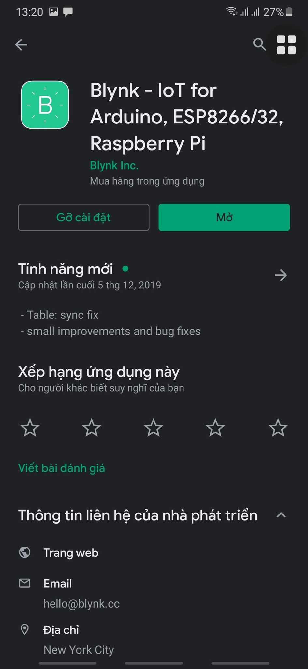

1. **Sign up for a Blynk account**

**Create new project (Note: Token will be sent toyour email email)**

Select hardware: WeMos D1

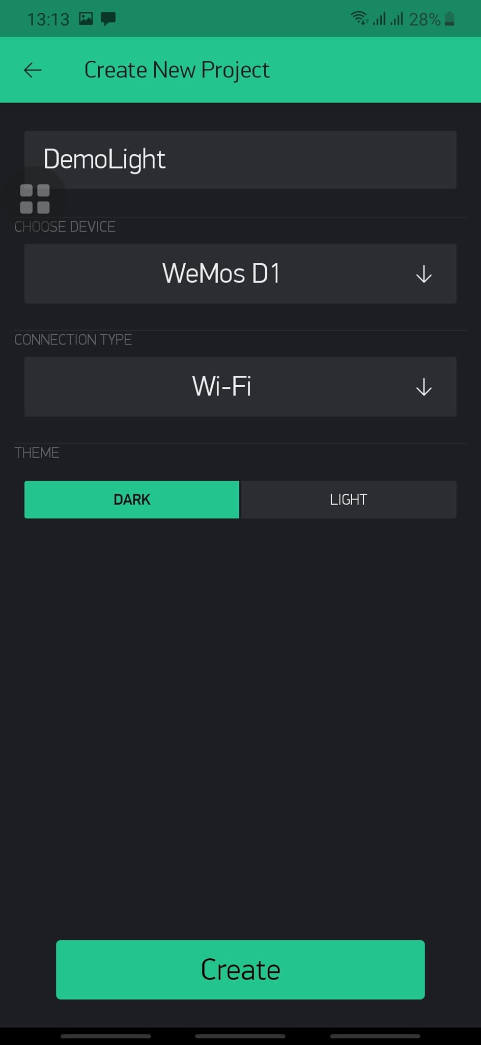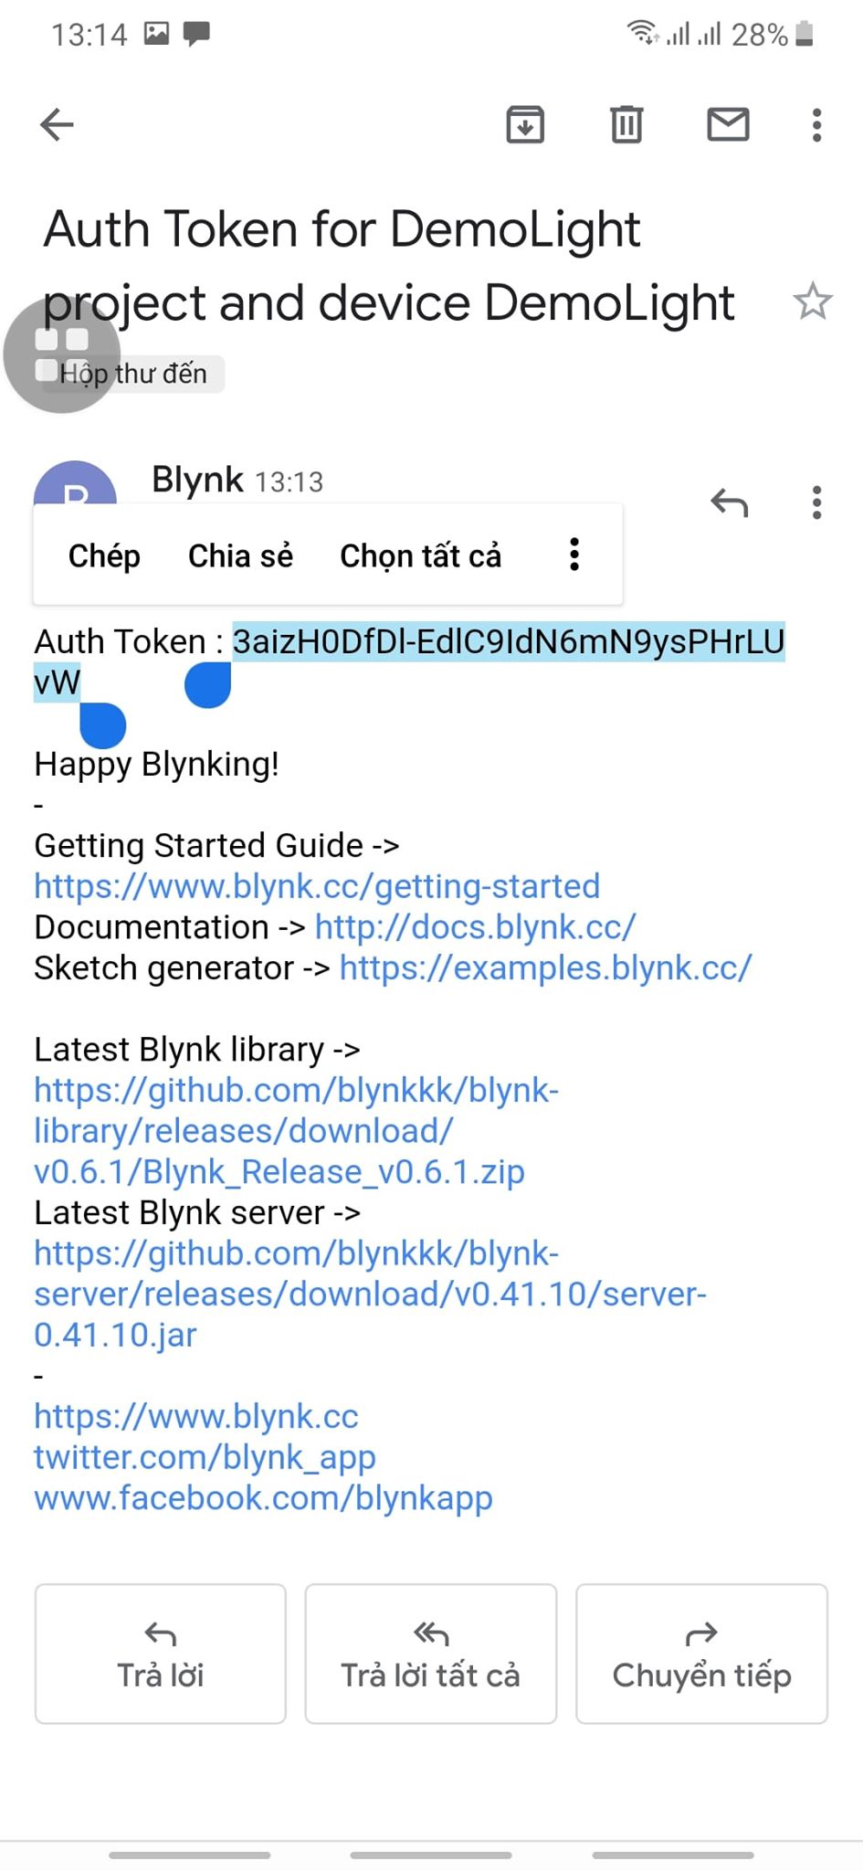

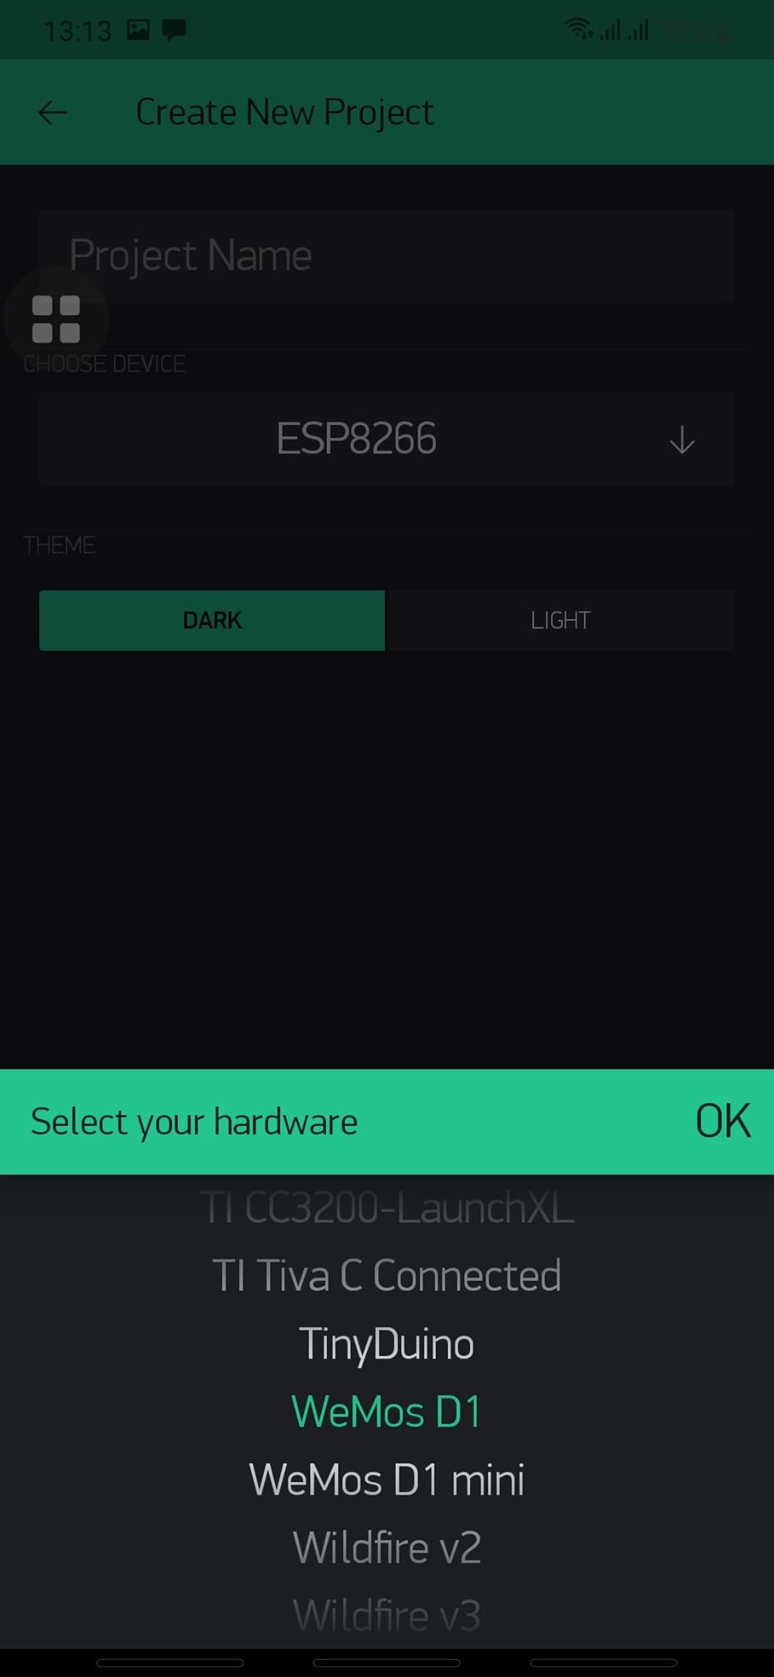

**Add a button on Blynk**

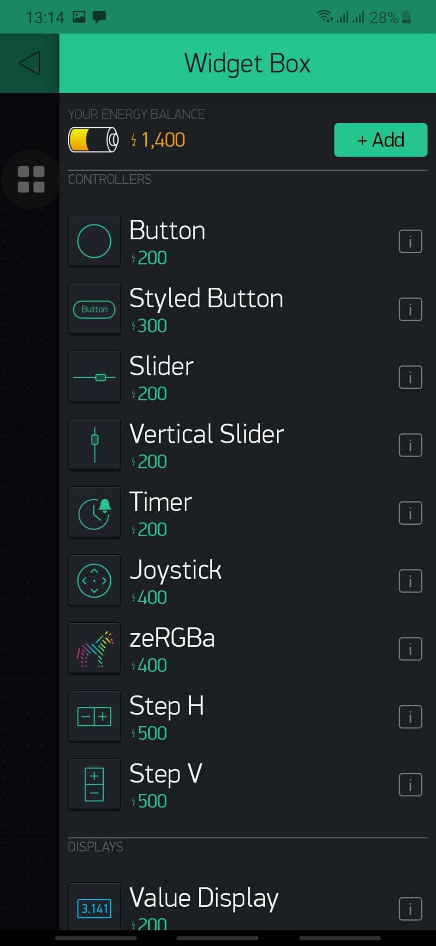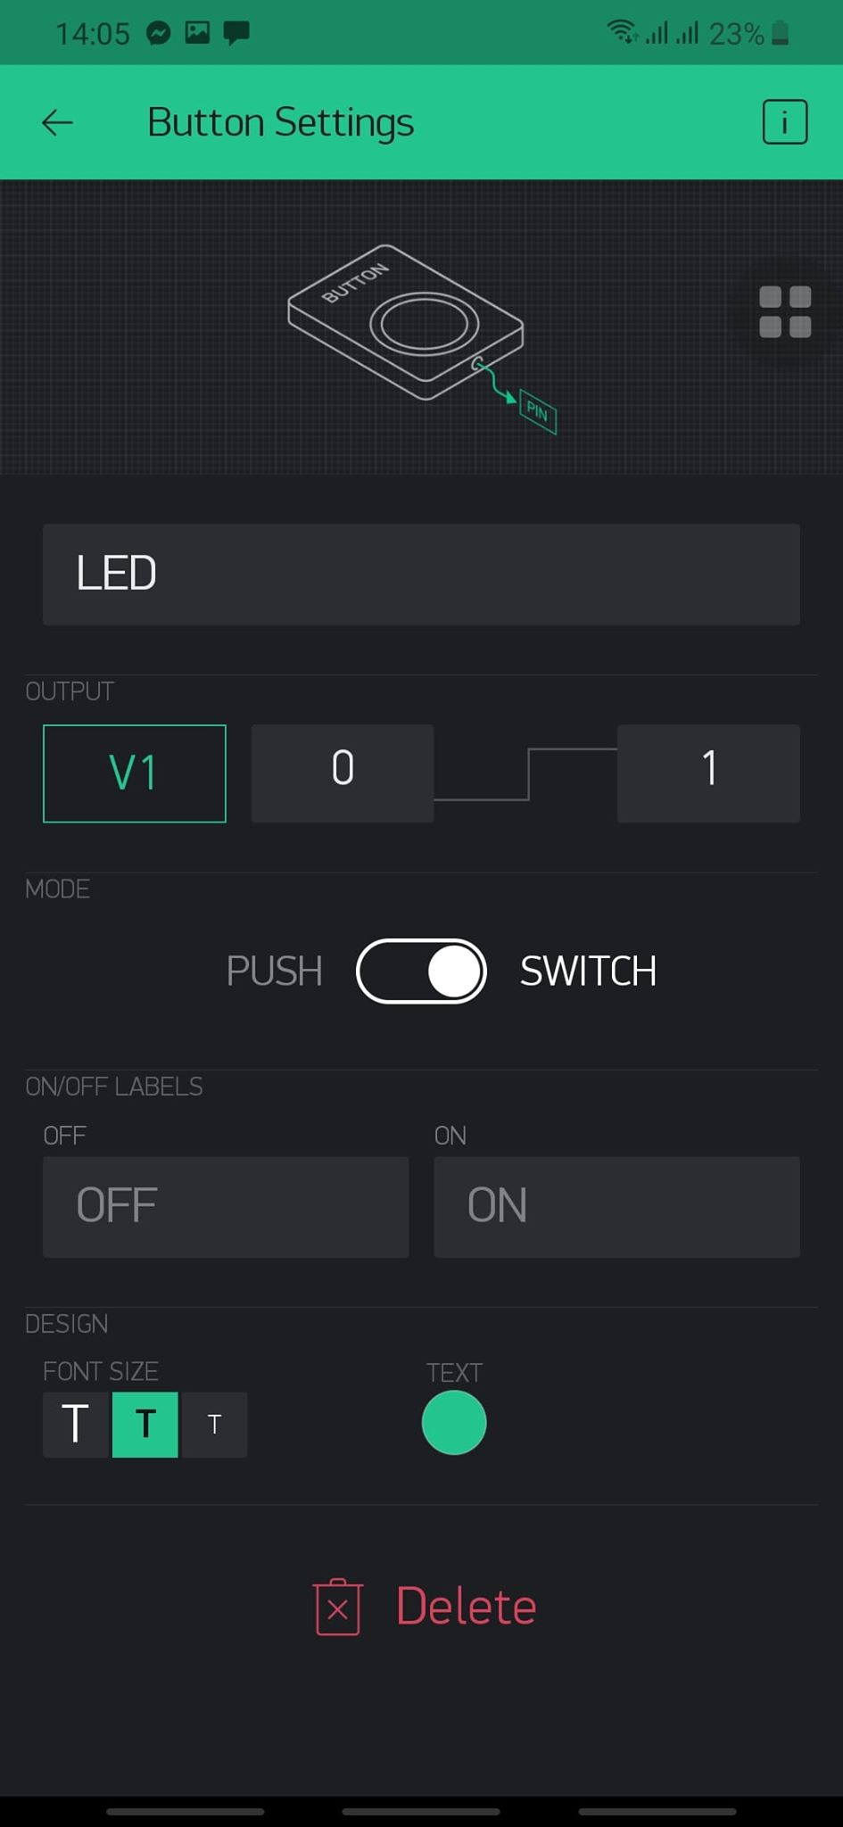

1. **Install Blynk library**

(How to install Blynk library: <http://help.blynk.cc/en/articles/512105-how-to-install-blynk-library-for-arduino-ide>)

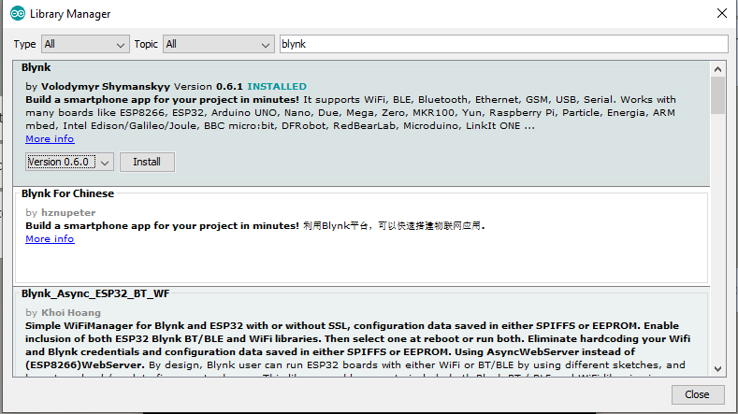

1. **Board Setup**

* From the Arduino IDE, select File>Preferences in menu bar
* Enter http://arduino.esp8266.com/stable/package_esp8266com_index.json in the **Additional Board Manager URLs** box.

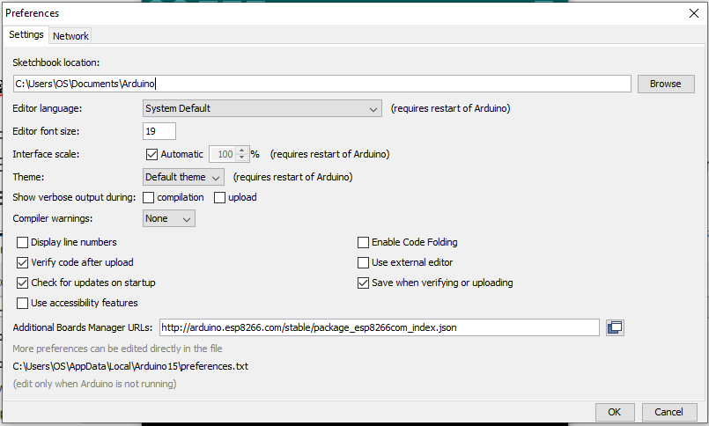

* SelectTools> Board menu > Boards Manager and search for **esp8266** platform.

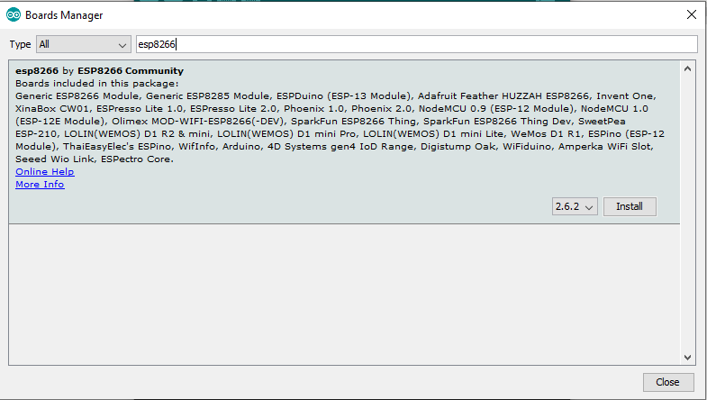

* Select the version from Drop-down list.
* Click **install.**

1. **The Schematic**

* We use the D2 pin for LED controlling.

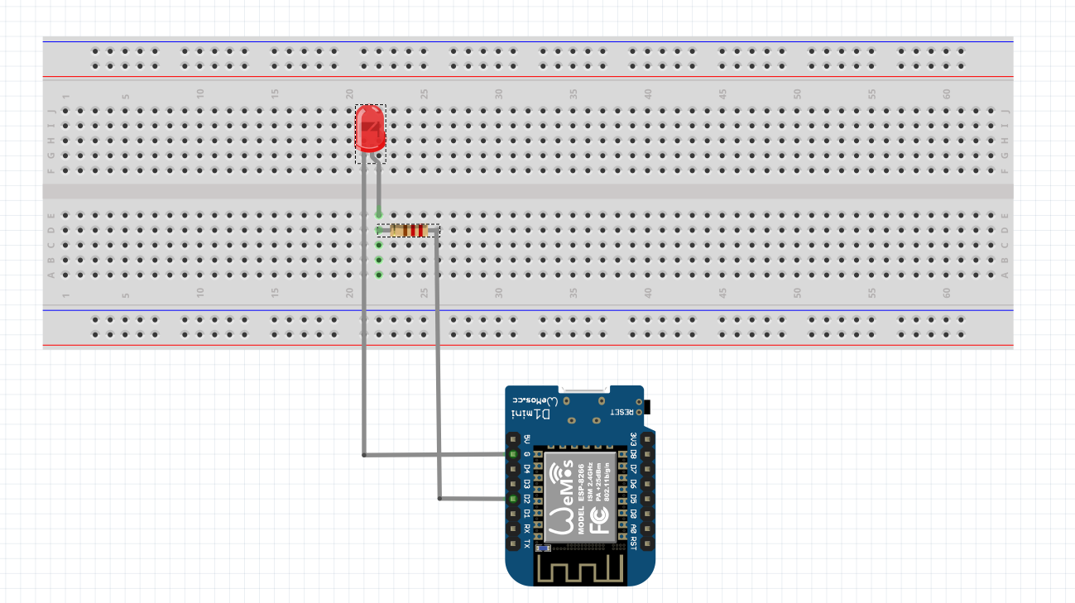

1. **Code the sketch**

#define BLYNK_PRINT Serial

#include <ESP8266WiFi.h>

#include <BlynkSimpleEsp8266.h>

// You should get Auth Token in the Blynk App.

char auth[] = "YOUR AUTH TOKEN KEY";

// Your WiFi credentials.

// Set password to Wifi networks.

char ssid[] = "Greenwich-Student";

char pass[] = "12345678";

void setup()

{

// Debug console

Serial.begin(9600);

Blynk.begin(auth, ssid, pass);

//Setup LED

pinMode(D2, OUTPUT);

}

//Setup for Blynk App to control Led

BLYNK_WRITE(V1)

{

int pinValue = param.asInt();

if(pinValue == 1)

{

digitalWrite(D2, HIGH);

}

else

{

digitalWrite(D2, LOW);

}

}

void loop()

{

Blynk.run();

}